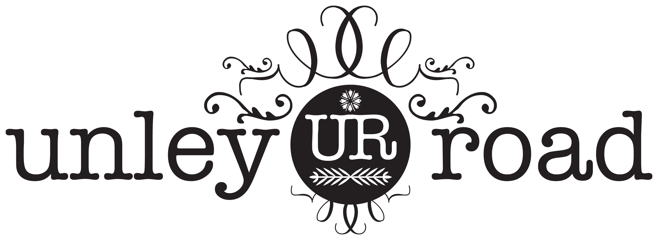
UNLEY ROAD ASSOCIATION
COMMITTEE NOMINATION FORM 2022

We, the members below, hereby nominate ………………………………………………………………………….. for election to the Committee of Unley Road Association Inc:
Member 1 Full Name ……………………………………………………………………………………………………………….
Member 1 Signature ……………………………………………………Date …………………………………………………….

Member 2 Full Name ……………………………………………………………………………………………………………….
Member 2 Signature ……………………………………………………Date …………………………………………………….
NOMINEES – PLEASE COMPLETE THIS SECTION
Nominee First Name …………………………………………..…….. Last Name…………….…………………..……………
Email Address……………………………………………………..…… Mobile phone ………………………………..…………
(for official correspondence)
Tick if agree:
[ ] I own property or lease a commercial based property on Unley Road or I am obliged to pay the Unley Road Separate Rate for such a property
or
[ ] I manage a business or am in a business operated at an address on Unley Road, or am obliged to pay the Unley Road Separate Rate
[ ] I agree with the Objectives of Unley Road Association Inc. as set out in the Constitution.
[ ] I agree to abide by the Association’s terms of the Constitution, Code of Conduct and Policies.
[ ] I agree to stand for nomination to the Committee of Unley Road Association Inc.
[ ] There is no reason under SA or Commonwealth legislation that I am disallowed from serving on the Committee.
Address of Unley Road property referred to above and Business Name (if relevant):
……………..…….…………………………….…………………………………………………………………………………….

Signature …………………..…….…………………………….……… Date ………………………………..…………………

Please scan and email this form to hello@onlyunleyroad.com.au or post it to PO Box 391, Unley 5061.

Nomination forms must be received by the Secretary before 5pm, 10 October 2022.
The Annual General Meeting will be held at 6pm on 16th November 2022 at the LA Scala

